Comprehensive Unit 2 Agile Mini-Project Report
Project Title: Student Record and Academic Management Platform
Course: B.Tech Mini-Project (Agile Software Development & DevOps Practices)

Student Name: Suraj Ganesh Sase
Programme / Branch: B.Tech — Artificial Intelligence and Data Science
Year / Semester: 2nd year, 3rd sem
College: Sanjivani University
Course / Trainer: karan Gaikwaad sir
Submission Date:19/08/2026

1. Introduction & Product Vision
1.1 Product Vision Statement
"Develop a secure and user-friendly Student Record and Academic Management Platform that enables educational institutions to efficiently manage student records, attendance, academic performance, course registration, and reporting through a scalable web-based application."
1.2 Agile Product Vision Parameters
- Overall Product Objective: Centralize all administrative and academic workflows into a single digital ecosystem.
- Primary Users: Students, Faculty Members, and Administrative Staff.
- Business Benefits: Minimizes paperwork, enhances data integrity, provides real-time academic tracking, and improves institutional communication.
- Measurable Success Criteria: Zero authentication breaches, minimal web latency (<2 seconds page load), and high user adoption rates across departments.
- Project Constraints: Adherence to institutional data privacy guidelines, fixed 2-week sprint durations, and limited team developer capacity.
1.3 Project Stakeholder Matrix
Stakeholder Role | Description | Key Responsibilities
Student | Primary end-user | View grades, check attendance records, and complete course registrations.
Faculty Member | Academic staff user | Record attendance, enter examination marks, and monitor class performance.
Administrator | System controller | Manage user accounts, setup academic courses, and generate official institutional reports.
2. Scrum Team Structure & Roles
Organizing students into high-performing cross-functional Scrum teams ensures clear accountability:
- Product Owner: Defines product requirements, prioritizes the Product Backlog, represents stakeholder interests, and accepts completed work.
- Scrum Master: Facilitates Scrum ceremonies, removes project impediments, ensures Agile practices are followed, and supports team collaboration.
- Development Team: Designs application architecture, writes code, tests software, prepares technical documentation, and demonstrates completed features.
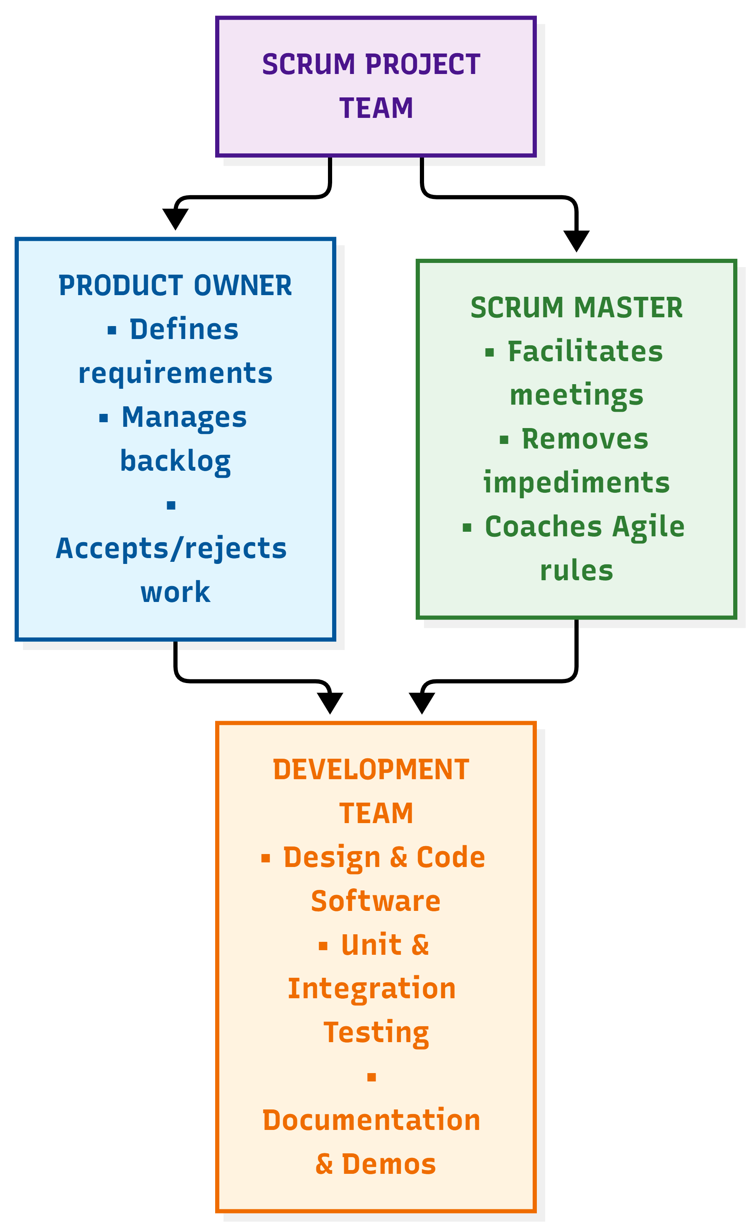3. Project Architecture & Visual Workflow
Below is the high-level system architecture and iterative Scrum workflow followed by student development teams:
[Product Discovery] ---> [Sprint Planning] ---> [Daily Standups] ---> [Sprint Review & Retrospective] ---> [MVP Delivery]
4. Project Epics & Functional Modules
The application is decomposed into 7 primary functional Epics:
- Epic 1 – Student Management: Student registration, profile management, search, update, and deletion.
- Epic 2 – Course Management: Add course, update course, assign students, and view details.
- Epic 3 – Attendance Management: Record attendance, view daily tracking, and generate attendance reports.
- Epic 4 – Marks & Academic Performance: Enter marks, update scores, calculate grades, and generate result sheets.
- Epic 5 – Authentication & Security: User login, logout, password reset, and role-based access control (RBAC).
- Epic 6 – Notifications: Automated attendance alerts, exam schedules, and result notifications.
- Epic 7 – Reporting: Comprehensive student, attendance, performance, and course reports.
5. User Stories & Acceptance Criteria Example
User Story Example
- As a: Faculty Member
- I want to: record student attendance
- So that: attendance records remain accurate and updated.
Acceptance Criteria (Definition of Done)
- Faculty can select a specific course.
- Faculty can select the lecture date from a calendar picker.
- Faculty can mark students as Present, Absent, or Late.
- Attendance records are saved securely to the database.
- Automated attendance reports can be exported.
5.1 Agile Quality Standards: Definition of Ready (DoR) & Definition of Done (DoD)
- Definition of Ready (DoR): A user story can only enter a sprint backlog if it has clear acceptance criteria, has been estimated via Planning Poker, and has been approved by the Product Owner.
- Definition of Done (DoD): A user story is marked complete only when code is written, unit tests pass successfully, code is peer-reviewed via GitHub, and features are deployed to the staging environment.
6. Prioritized Product Backlog & Effort Estimation
Backlog items are evaluated through Planning Poker and prioritized based on business value, user importance, technical dependencies, and implementation complexity.
Priority | Epic | User Story | Story Points | Complexity
High | Authentication | User Login | 3 | Moderate
High | Student Management | Add Student | 5 | Difficult
High | Student Management | Search Student | 3 | Moderate
High | Attendance | Record Attendance | 5 | Difficult
Medium | Course Management | Add Course | 3 | Moderate
Medium | Reporting | Attendance Report | 8 | Very Difficult
Medium | Notifications | Attendance Alert | 5 | Difficult
Low | Dashboard | Academic Analytics | 13 | Highly Complex
6.1 Technical Risk Assessment & Mitigation
- Identified Risk: Database concurrency issues when multiple faculty members submit attendance records simultaneously.
- Mitigation Strategy: Implement database connection pooling, indexing on foreign keys (course_id and student_id), and backend request throttling.
7. Sprint Planning & Execution Board
- Sprint 1 (Goal: Authentication & Setup): Repository init, database connection, user registration, and login interface.
- Sprint 2 (Goal: Student Management): Build Add, Search, Update, and Delete student features.
- Sprint 3 (Goal: Courses & Attendance): Implement course registration, student assignment, and daily attendance recording.
7.1 Sprint Velocity & Capacity Calculation
- Team Size: 4 Student Developers.
- Available Working Hours: 40 hours per 2-week sprint.
- Estimated Team Velocity: 15 Story Points per sprint, ensuring workloads are balanced and achievable without overburdening team members.
7.2 Scrum Kanban Board Simulation
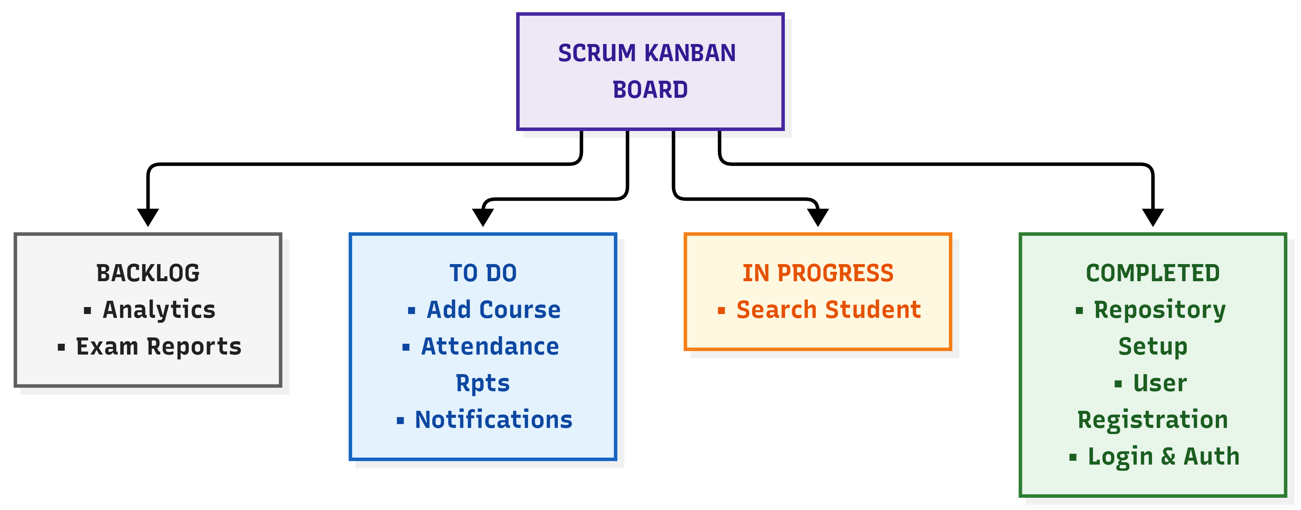8. Scrum Ceremonies & Retrospective Framework
- Sprint Planning & Daily Standups: Teams conduct 15-minute daily meetings answering: What did I complete yesterday? What will I do today? What blockers do I face?
- Start, Stop, Continue Retrospective Framework:
  - Start Doing: Automated CI/CD pipeline tests before merging code branches.
  - Stop Doing: Leaving backlog grooming and refinement until the final day of the sprint.
  - Continue Doing: Maintaining clear daily communication via team channels.
9. Student Deliverables Checklist
Students are required to compile and submit the following artifacts upon unit completion:
- [ ] Agile Project Planning Report & Product Vision Document
- [ ] Scrum Team Structure & Roles Document
- [ ] Epic Documentation & User Story Repository
- [ ] Acceptance Criteria & Story Point Estimation Sheet
- [ ] Sprint Backlog, Scrum Board, and Burndown Charts
- [ ] Sprint Review & Retrospective Reports
- [ ] Framework Comparison Report & Release Roadmap

